

Student Name……………………………………

FURTHER MATHEMATICS

TRIAL EXAMINATION 2

(ANALYSIS TASK)

2002

Reading Time: 15 minutes
Writing time: 90 minutes

Instructions to students
This exam consists of Section A and Section B.
Section A contains a set of extended answer questions from the core, “Data Analysis”.
Section A is compulsory and is worth 15 marks.
Section B consists of 5 modules. You should choose 3 of these modules and answer every question in each of your chosen modules. Each of the modules is worth 15 marks.
There is a total of 60 marks available for this exam.
The marks allocated to each of the four questions are indicated throughout.
Students may bring up to two A4 pages of pre-written notes into the exam.
Formula sheets can be found on pages 26-27 of this exam.

This paper has been prepared independently of the Victorian Curriculum and Assessment Authority to provide additional exam preparation for students. Although references have been reproduced with permission of the Victorian Curriculum and Assessment Authority, the publication is in no way connected with or endorsed by the Victorian Curriculum and Assessment Authority.

© THE HEFFERNAN GROUP 2002
This Trial Exam is licensed on a non transferable basis to the purchaser. It may be copied for educational use within the school which has purchased it. This license does not permit distribution or copying of this Trial Exam outside that school or by any individual purchaser.

Section A

Core

Question 1

The number of hotdogs sold on a Sunday during the 2001 season at the canteens of the Blacktown Football Club and the Fairmeadows Football Club are shown in Table 1 below.

No. of hotdogs  sold at  Blacktown FC | No. of hotdogs  sold at  Fairmeadows FC
51 | 93
62 | 107
84 | 111
97 | 101
40 | 95
103 | 114
58 | 125
75 | 150
105 | 102
108 | 103
92 | 90
81 | 132
69 | 128
47 | 102
79 | 99
110 | 115
Table 1
A box plot showing the distribution of the number of hot dogs sold on Sundays during the 2001 season at the Blacktown Football Club canteen is shown in Figure A below.
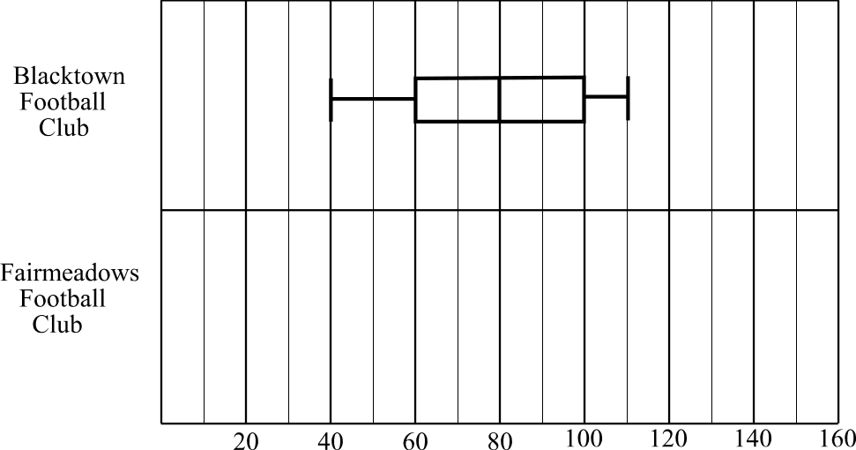
Figure A

- On Figure A above, in the space provided draw a correctly scaled box plot displaying the distribution of the number of hot dogs sold on Sundays during the 2001 season at the Fairmeadows Football Club canteen. Use the data given in Table 1 to do this.
2 marks
b. Using the two box plots in Figure A write 3 sentences. These 3 sentences should
describe any differences or similarities between the distributions of Blacktown and
Fairmeadows in terms of their shape, their centres and their spreads.

(shape)

(centre)

(spread)

3 marks

Question 2

The data shown in Table 2 below was collected at the Blacktown Football Club canteen one Sunday. It shows the age bracket and the type of item purchased for those people who bought just one item at the canteen.

Age bracket | Type of item purchased |  |  |  | Total
 | Hot food | Cold drink | Confectionery | Hot drink
18 and over | 143 | 23 | 27 | 75 | 268
Under 18 | 62 | 87 | 59 | 21 | 229
Total | 205 | 110 | 86 | 96 | 497
Table 2

- Of the people under 18 who bought just one item at the canteen, how many bought confectionery?

1 mark

The table was percentaged by calculating row percentages, correct to the nearest whole percentage, as shown in Table 3 below.

Age bracket | Type of item purchased |  |  |  | Total
 | Hot food | Cold drink | Confectionery | Hot drink
18 and over (%) | 53 | 9 | 10 |  | 100
Under 18 (%) | 27 | 38 | 26 | 9 | 100
Table 3

- Complete Table 3 by calculating the percentage of people 18 and over who bought a hot drink? (Express your answer to the nearest whole percentage.)
1 mark

- Use Table 3 to describe any relationship that is evident between the type of items purchased and the age bracket of the purchasers.

2 marks
Question 3

The number of hot dogs sold on a Sunday at the Blacktown Football Club canteen and the maximum temperature on that Sunday is given in Table 4 below.

Number of  hot dogs sold | Maximum temperature  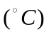
51 | 23
62 | 21
84 | 19
97 | 16
40 | 24
103 | 12
58 | 22
75 | 18
105 | 15
108 | 14
92 | 17
81 | 19
69 | 20
47 | 21
79 | 19
110 | 14
Table 4

- If you investigated the relationship between the number of hot dogs sold and the maximum temperature, which would be the dependent variable?

1 mark

The scatterplot below in Figure A plots the data shown in Table 4.

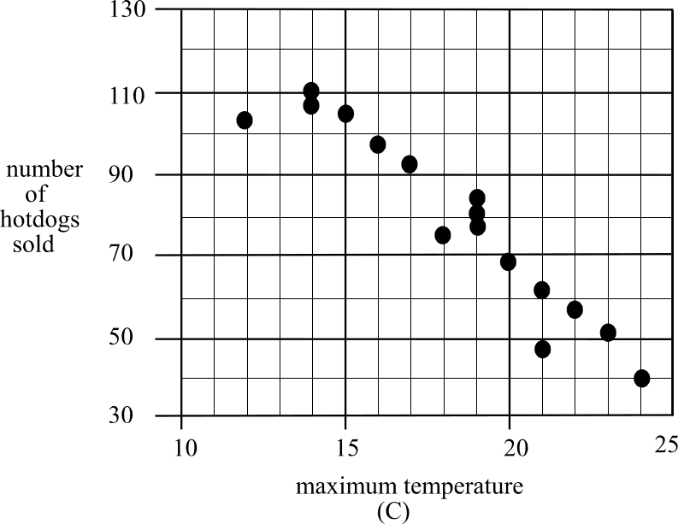

Figure A
- A least squares regression line is to be fitted to this data. In order to do this, what do we assume about the relationship between the maximum temperature and the number of hot dogs sold?

1 mark

- Write down in the spaces provided the equation of the least squares regression line.
Express the numbers entered correct to 2 decimal places.

number of hotdogs sold = maximum temperature +

2 marks

- i. Calculate the value of the Pearson’s product moment coefficient to 4 decimal places.

r =

1 mark

  - For this data we can conclude that % of the variation in the number of hotdogs sold can be explained by the variation in the maximum temperature of the day.
1 mark
Total 15 marks

Section B

Section B consists of 5 modules. Select any 3 modules and answer every question in each of those chosen modules.

Module 1: Number patterns and applications

If you choose this module, all questions must be answered.

Question 1

The owners of the Corkvale winery signed a contract to export cases of wine. In 2001, the first year of the contract, 240 cases of wine were exported. There is to be an increase of 50 cases each year thereafter.

- How many cases of wine are to be exported according to the contract in 2002?

1 mark

- How many cases of wine are to be exported according to the contract in 2005?

1 mark

- During which year will the number of cases to be exported for that year, according to the contract, first exceed 750?

1 mark

- The winery’s contract is for 15 years. How many cases of wine will the winery have exported in total during those 15 years?

2 marks

Question 2

The number of cases of wine that the winery expects to produce for the domestic market can be described by the difference equation

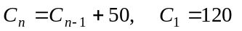
where 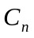is the number of cases produced in the nth year.

- If  is the number of cases of wine produced for the domestic market in 2001, how many cases of wine does the winery expect to produce for the domestic market in 2003?

1 mark

- What is the annual increase in the number of cases of wine expected to be produced for the domestic market?

1 mark

- In which year is the ratio of the number of cases of wine produced for the export market compared to the number of cases of wine produced for the domestic market, 2:1.

1 mark

- In a particular year, the ratio of the number of cases of wine to be produced for the export market compared to the number of cases of wine to be produced for the domestic market is 7:6.
Given that the total number of cases of wine produced for both markets that year is to be 1560, how many of these cases would be for the domestic market?

2 marks

Question 3

According to the export contract, the payment received per case of wine exported by the winery each year, follows the formula

- How much will the winery be paid per case of wine exported in 2007?

1 mark

- Which year is the first year that the winery will receive more than $150 per case of wine that is exported?

1 mark

- How much should the winery be paid in 2003 for all the wine it exports that year?

1 mark

- According to the export contract, what is the total payment the winery should receive for exporting one case of wine each year for 15 years?

2 marks
Total 15 marks

Module 2: Geometry and Trigonometry

If you choose this module, all questions are to be answered.

Question 1

A brick fence of height 3 metres has been pushed sideways by tree roots. It now stands at an angle of 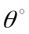 to the vertical. The top of the fence is 0.5 metres from the vertical. The vertical height of the fence above the ground is h metres as indicated by the side view shown in Figure A below.

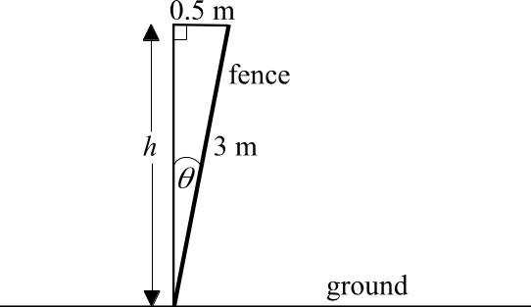

Figure A

- Find h in metres. Express your answer correct to 2 decimal places.

2 marks

- Find . Express your answer to the nearest minute.

2 marks

Question 2

Metal struts anchored by pegs have been placed along the fence to support the fence as indicated in Figure B.

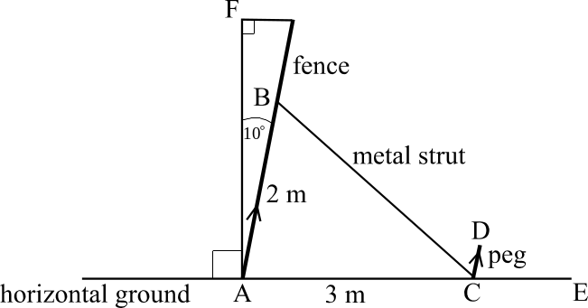

Figure B

The struts are attached 2 metres up the wall at point B and are anchored at point C on the ground by the pegs, which are metal rods of length CD. The distance AC is 3 metres.
The pegs, indicated in Figure B by CD, run parallel with the fence, which is indicated by AB. By the time the metal struts had been put in place, the wall had leant further over to be at an angle of exactly 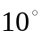 with the vertical.

- Find 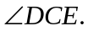

1 mark

- Find the length of the metal strut. Express your answer correct to 1 decimal place.

2 marks

- Use your answer to part b. to find 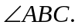 Express your answer to the nearest minute.

2 marks
Question 3

The fence is made up of 8 panels of brickwork. Each of these panels is equal in width.
The front on view of the fence is shown in Figure C below.

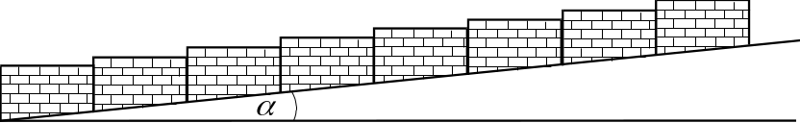

Figure C

The start and finish of the fence are indicated on the contour map in Figure D below.

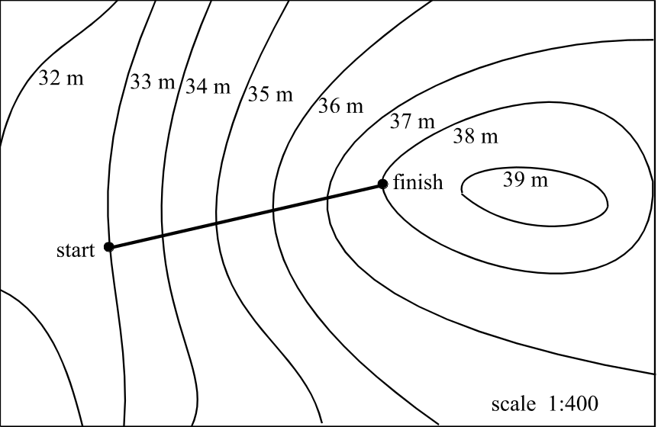

Figure D

The scale on the contour map is 1:400 and the distance between the start and the finish of the fence on the contour map is 11cm.

- Show that the actual horizontal distance between the start and the finish of the fence is 44m.

1 mark

- Find the actual distance between the start and the finish of the fence. Express your answer in metres correct to 1 decimal place.

1 mark

- Hence find the angle shown in Figure C. Express your answer to the nearest minute.

1 mark

- Find the difference in height, d, in metres, between the bottom left hand corner of the first panel on the left and the bottom left hand corner of the sixth panel from the left as indicated in Figure E below. Express your answer correct to 2 decimal places.

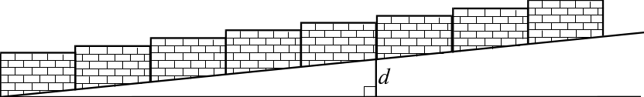

Figure E

3 marks
Total 15 marks

Module 3: Graphs and relations

If you choose this module, all questions are to be answered.

A coffee machine used in a café has a 20-litre water tank. As coffees are made, the water level in the tank drops.
The café opens at 10am and the amount of water in this tank over the first 30 minutes of business is shown on the graph in Figure A below.

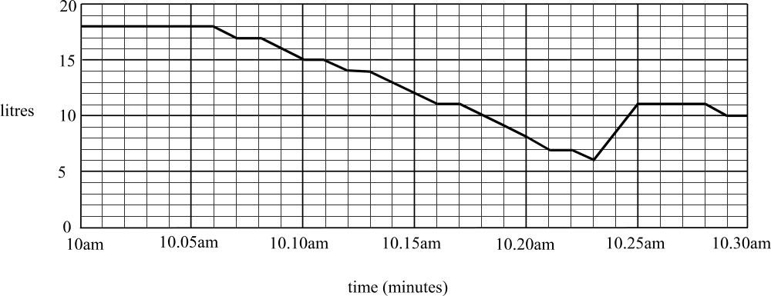

Figure A

Question 1

- How many litres of water were in the tank when the café opened?

1 mark

- During the first 30 minutes of business a waiter added water to the tank.

  - How many litres of water were in the tank when the waiter began to add water to the tank?

1 mark

  - How many litres of water were added to the tank?

1 mark

  - How many minutes after this water had finished being added, was the next coffee made?

1 mark

- What is the average rate of change of the amount of water in the tank expressed in litres per minute, between 10.05am and 10.23am?

1 mark

Question 2

Let C represent the number of cups of coffee sold at the café per day. Let S represent the number of serves of cake sold at the café per day. The owner of the café has found that in order for the café to run well, there are four constraints, which must be satisfied.
The first two, expressed algebraically are
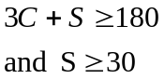
The third is that the number of serves of cake served in a day and the number of cups of coffee served in a day, in total, must be less than or equal to 140.

- Express this third constraint algebraically.

1 mark

The fourth constraint is that the maximum number of coffees that can be made in a day is 100.

- Express this constraint algebraically.

1 mark
A graph showing the equations 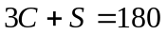 and 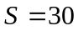 is given in Figure B below.
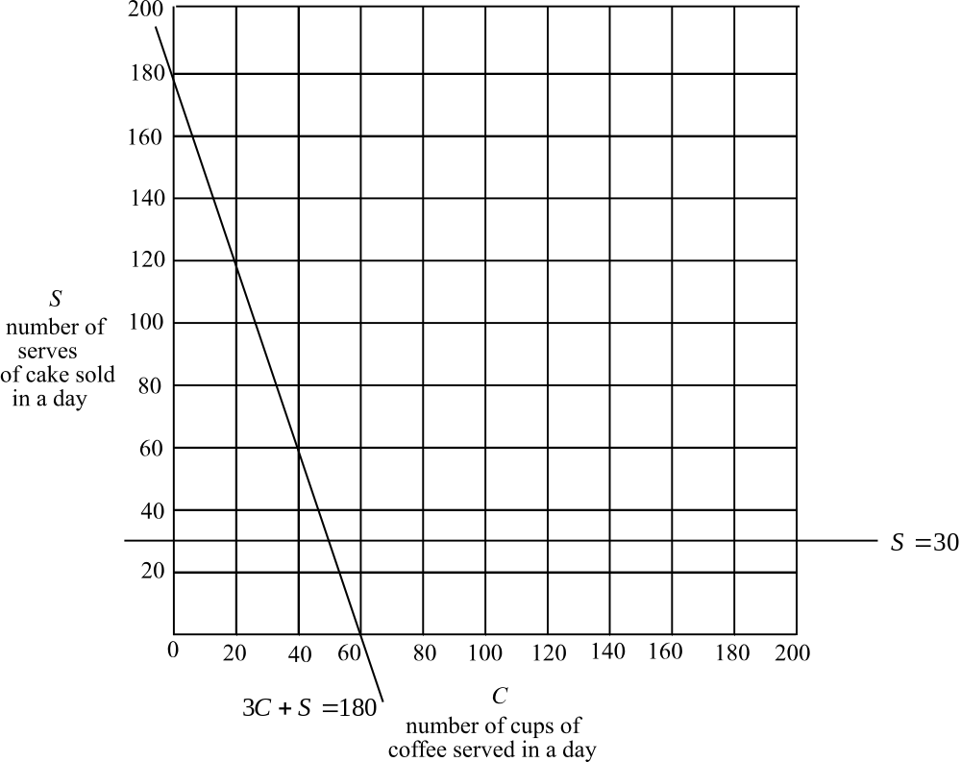

Figure B
c. On the same graph, sketch the two constraints found in part a. and part b.

2 marks

d. Indicate clearly on the graph the feasible region defined by the four constraints.

1 mark

Question 3

The owner of the café makes a profit of $2 on each cup of coffee sold and $3 on each serve of cake sold.

- Write down an expression for P, in dollars, which represents the profit made in a day from the sale of cups of coffee and serves of cake.

1 mark

- Find the corner points of the feasible region and hence calculate the maximum profit that can be made in a day from the sale of cups of coffee and serves of cake.

4 marks
Total 15 marks

Module 4: Business related mathematics

If you choose this module, all questions are to be answered.

Question 1

Harold’s television set breaks down. He considers buying another one and finds a set he likes which costs $2200. He can pay for the set on hire purchase over two years at $120.00 a month and with no deposit.

- i. What is the total amount Harold will pay for the set according to this deal?

1 mark
  - How much interest will Harold pay?

1 mark

    - What is the flat rate of interest per annum with this deal? Express your answer as a percentage correct to one decimal place.

2 marks

    - What is the approximate effective rate of interest per annum with this deal? Express your answer as a percentage correct to one decimal place.

1 mark

    - Harold decides to have his old television set repaired. This old set lasts another four years. Harold then decides that he must buy a new set. If the set he looked at 4 years ago had risen in price only because of inflation and if inflation had averaged 2% per annum over the 4 years, how much would the set now cost?

1 mark
Question 2

Harold is retired and has his superannuation payout invested in various locations.

- When Harold first retired he invested $30000 in a bank, which offered 8% interest compounding quarterly. Calculate the amount of interest earned by Harold after 7 years? Express your answer to the nearest cent.

2 marks

- In another investment, he invested $20000 and earned 6% per annum compound interest in an account in which interest was calculated every six months. At the end of the investment the amount in his account was $26 878.33. How many years was this money invested for?

2 marks

Question 3

Harold wants to help out his son Norm. Rather than pay a lump sum, Harold sets up an annuity, which will provide a monthly payment of $200 to Norm.
Harold invests $20 000 at an interest rate of 6% per annum compounding monthly. The money is paid to Norm immediately after the interest is paid into the account and Norm receives his first payment one month after Harold takes out the investment.

- Using the annuity formula,
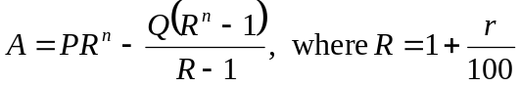,
- Write down the value of Q for this investment.

1 mark

- Calculate how much is left in Harold’s account after 5 years. Express your answer to the nearest cent.

2 marks

- If Harold wanted Norm to receive monthly payments for 3 years, whilst retaining the original investment of $20 000 at the same rates. What monthly payment would be paid to Norm?

2 marks
Total 15 marks

Module 5: Networks and decision mathematics

If you choose this module, all questions are to be answered.

A parcel distribution company has seven warehouses of varying sizes spread around the suburbs. Parcels are sometimes moved between warehouses before distribution.
A network showing these seven warehouses together with the regular routes used between them is shown in Figure 1 below.

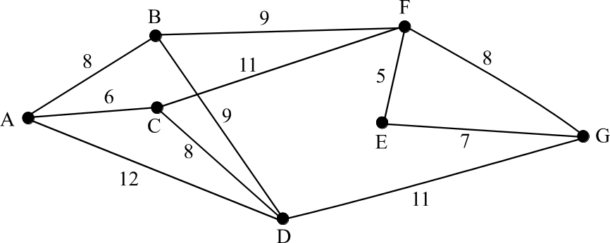

Figure 1

The numbers represent the shortest distance, in kilometres, between the respective warehouses.

Question 1

- Write down a Hamiltonian circuit for this network beginning and ending at A.

1 mark

- Explain whether or not a driver can leave warehouse A and travel on each of the regular routes just once before returning to warehouse A.

1 mark

- Find the minimum distance between warehouse A and warehouse G on this network.

1 mark

d. To cut costs some of the regular routes have to be abandoned.
The revised network will be a minimum spanning tree.
On the diagram below, draw in the minimum spanning tree.

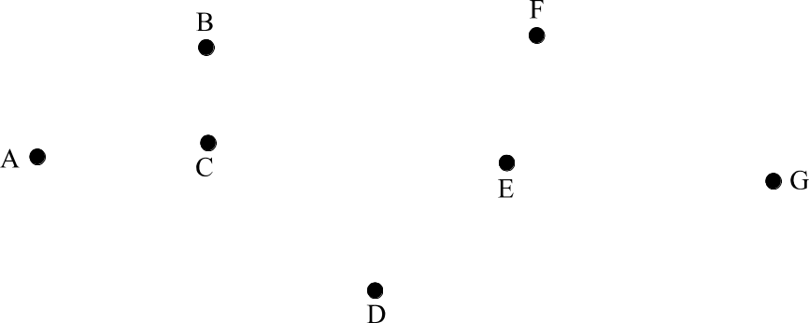

2 marks

Question 2

The company is building a new warehouse. A network showing the activities involved in the building of this warehouse, together with the time taken, in weeks, to complete each of the activities is shown below in Figure 2.
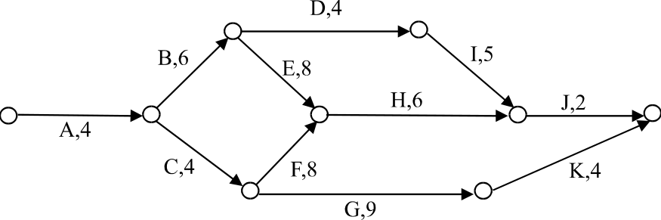

Figure 2

Table 1 below lists the activities involved in the building of this new warehouse together with the time taken to complete each of them and the activities, which must precede them.

Activity | Time taken to  complete (weeks) | Immediate  Predecessor(s)
A | 4 | -
B | 6 | A
C | 4 | A
D | 4 | B
E | 8 | B
F | 8 | C
G | 9 | C
H | 6
I | 5 | D
J | 2 | H, I
K | 4 | G
Table 1

- By referring to the network given in Figure 2, complete Table 1.
1 mark

- Complete Table 2 below by entering the relevant earliest start time and latest start time.
Activity | Earliest start time | Latest start time
A | 0 | 0
B | 4 | 4
C | 4 | 6
D | 10
E | 10 | 10
F | 8 | 10
G | 8 | 13
H |  | 18
I | 14 | 19
J | 24 | 24
K | 17 | 22
Table 2
2 marks
c. Write down the critical path for the building of the warehouse.

1 mark

d. How long will it take to complete the building?

1 mark

Question 3

The only activities, which can be reduced in the time taken to complete them, are activities B, C, D, and E. The maximum number of weeks that each of these activities can be reduced together with the cost, per week, of making such reductions is shown in Table 3 below.

Activity | Cost  per week | Maximum  reduction  possible in  weeks
B | $3000 | 3
C | $1000 | 3
D | $2000 | 2
E | $2000 | 1
Table 3

- Using the network shown below or otherwise, find the shortest time that the building will now take to complete if these time reductions are implemented.

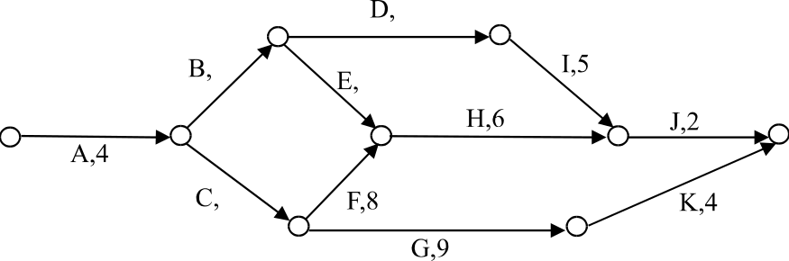

2 marks

- Find the minimum cost for this to happen.

3 marks
Total 15 marks
Further Mathematics Formulas

Business-related mathematics

simple interest: 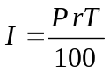
compound interest: 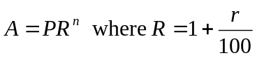
hire purchase: 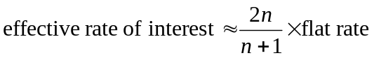
annuities: 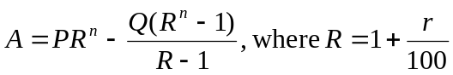

Geometry and trigonometry

area of a triangle: 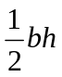
area of a triangle: 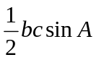
area of circle: 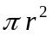
volume of sphere: 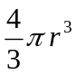
volume of cone: 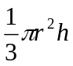
Pythagoras’ theorem 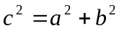
sine rule: 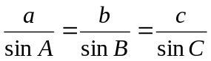
cosine rule: 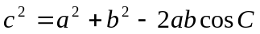

Graphs and relations

Straight line graphs

gradient: 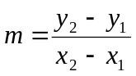
equation: 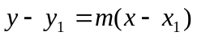 gradient-point form

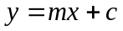 gradient-intercept form
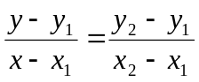 two-point form

Reproduced with permission of the Victorian Curriculum and Assessment Authority.
(These formula sheets have been copied from the 2001 Further Maths Exam 1. Teachers and students are reminded that changes to formula sheets are notified in the VCE Bulletins and on the VCAA website.).

Number patterns and applications

arithmetic series: 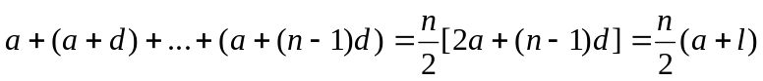
geometric series: 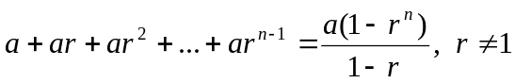
infinite geometric series: 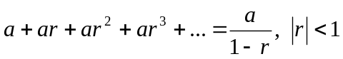
linear difference equations: 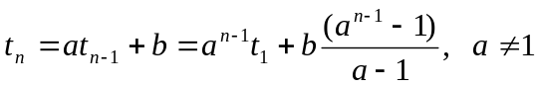
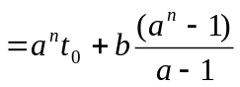

Networks and decision mathematics

Euler’s formula: 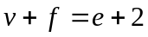

Statistics

seasonal index: 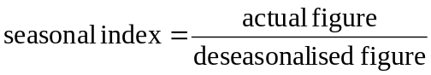

Reproduced with permission of the Victorian Curriculum and Assessment Authority.
(These formula sheets have been copied from the 2001 Further Maths Exam 1. Teachers and students are reminded that changes to formula sheets are notified in the VCE Bulletins and on the VCAA website.).

